Class Elections
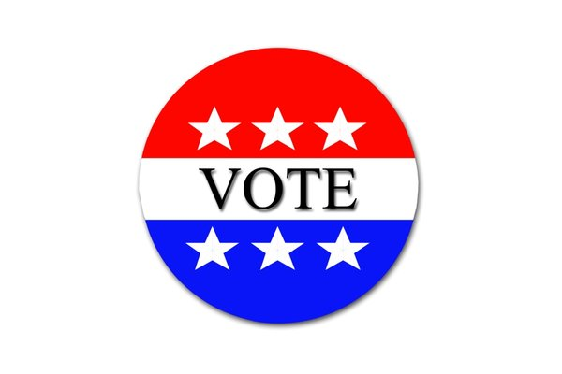
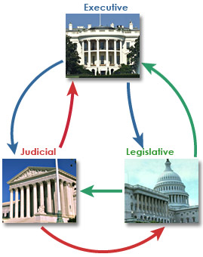
Class elections are about a sheriff, mayor, deputy, judicial branch, city council, Legislative branch, and executive branch Want to get voted for? You can make campaign signs! You can vote for people you think would do well. If you win you have to take a speech and the oath.

