We have had fun making our map projects so far. If you go above and beyond, your project has the chance to get hung up, but you don’t have to. All you
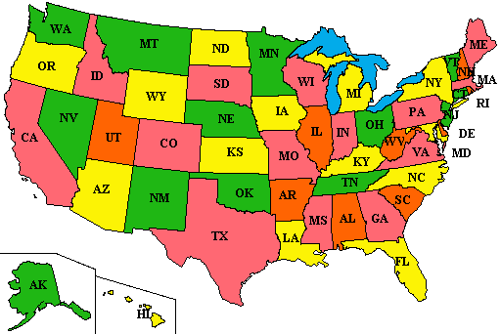

have to do is color neatly, label all the 12 states and capitals in the Southeast reign. And you’ll get a 5 on your project. And when we vote for our top project, we all have a say!

